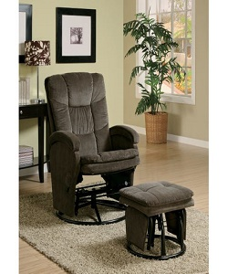

Rocking Chair

$84.96

Availability: In stock

### Description

Home swivel gliding rocker recliner glider with ottoman black leatherette reviews leather chair with small table. This Glider recliner with Ottoman is an ideal example of when traditional style meets modern comforts. The high-quality faux leather upholstery will add a touch of class when placed in your living room or study. It comes with a Recline feature and track arms that give it excellent comfort. The matching ottoman offers same plush seat and gliding functionality of the chair. This Glider Recliner with Ottoman is extremely hassle-free to clean. Simply use a dry cloth to wipe its surface.